screenshot of each command with the output:

1. Pwd: Print the name of the [working directory](https://www.computerhope.com/jargon/c/currentd.htm).

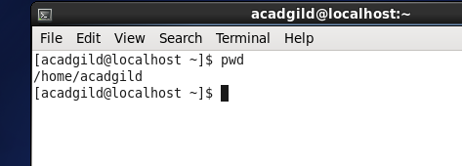

1. Vi: vi is actually the command which starts the visual mode of [ex](https://www.computerhope.com/unix/uex.htm), the landmark editing program developed by Joy. As ex gained popularity, Joy noticed that most users were exclusively using its visual mode, so to make things more convenient for his users, he added a link to ex which started it in visual mode automatically. Today vi is the most popular text editor among [Linux](https://www.computerhope.com/jargon/l/linux.htm) users.

Example:vi myfile.txt

Edits the file myfile.txt.

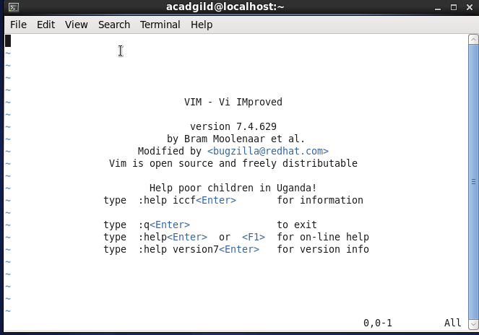

1. Touch: touch changes file [timestamps](https://www.computerhope.com/jargon/t/timestam.htm). It is also an easy way to create empty files.

Example: touch --time=01020304 file1.txt

Set the atime and mtime of file1.txt to January 2, 3:04 AM of the current year. The ctime is set to the current system time.

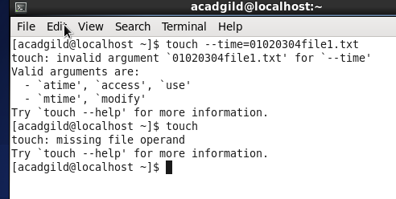

1. mkdir: The mkdir command creates new [directories](https://www.computerhope.com/jargon/d/director.htm) in your [file system](https://www.computerhope.com/jargon/f/filesyst.htm).

Example: mkdir myfiles

Create a new directory called myfiles in the current directory.

Directory created shaik

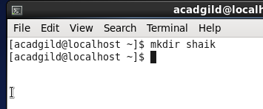

That’s why it is saying already exist I below screen shot

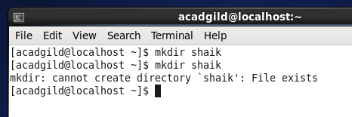

5.rm: rm removes each specified FILE. By default, it does not remove directories; see [Removing Directories](https://www.computerhope.com/unix/urm.htm#Removing-Directories) below for details.

Example: rm myfile.txt

Remove the file myfile.txt. If the file is write-protected, you will be prompted to confirm that you really want to delete it.

Removed all files present in shaik directory

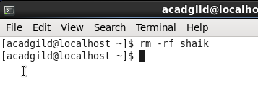

6.ls: Lists the contents of a [directory](https://www.computerhope.com/jargon/d/director.htm).

Example: ls –l

Lists the total files in the directory and subdirectories, the names of the files in the current directory, their permissions, the number of subdirectories in directories listed, the size of the file, and the date of last modification.

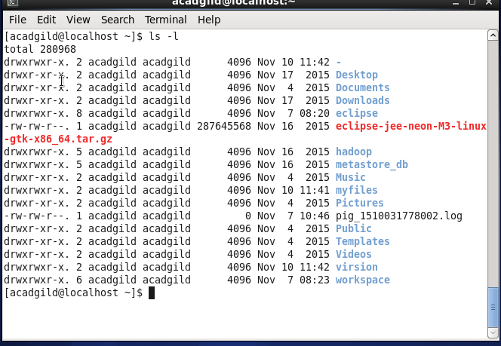

7.echo: echo is a fundamental command found in most [operating systems](https://www.computerhope.com/os.htm) that offer a [command line](https://www.computerhope.com/jargon/c/commandi.htm). It is frequently used in [scripts](https://www.computerhope.com/jargon/s/script.htm), [batch files](https://www.computerhope.com/jargon/b/batchfil.htm), and as part of individual commands; anywhere you may need to insert text.

Example: echo Hello, World!

Outputs the following text:

Hello, world!

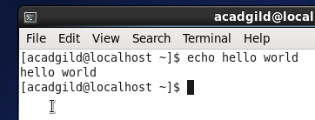

8. cat: cat stands for "catenate." It reads [data](https://www.computerhope.com/jargon/d/data.htm) from [files](https://www.computerhope.com/jargon/f/file.htm), and outputs their contents. It is the simplest way to display the contents of a file at the [command line](https://www.computerhope.com/jargon/c/commandi.htm).

Example: cat file.txt

Read the contents of file.txt and display them on the screen.

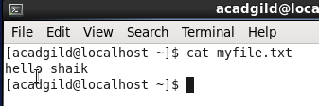

9. who: Displays who is [logged on](https://www.computerhope.com/jargon/s/signon.htm) to the [system](https://www.computerhope.com/jargon/s/system.htm).

Example:Who

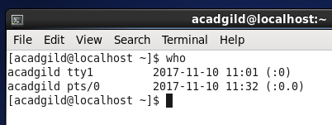

Displays the username, line, and time of all currently logged-in sessions.

10.cd: The cd command, which stands for "change directory", changes the [shell](https://www.computerhope.com/jargon/s/shell.htm)'s [current working directory](https://www.computerhope.com/jargon/c/currentd.htm).

Example: cd hope

The above example would change the working directory to the hope subdirectory if it exists.

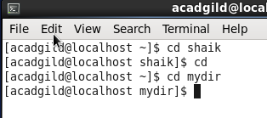

11.date: The date command is used to print out, or change the value of, the system's time and date information.

Example: date

Running date with no options will output the system date and time, as in the following

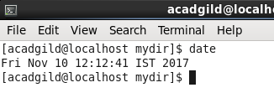

12.cal: Display a conveniently-formatted calendar from the command line.

Example:cal

Displays the calendar for this month.

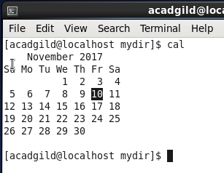

13.mv: The mv command moves, or [renames](https://www.computerhope.com/jargon/r/rename.htm), files and directories on your [filesystem](https://www.computerhope.com/jargon/f/filesyst.htm).

Example: mv myfile.txt myfiles

Move the file myfile.txt into the directory myfiles. If myfiles is a file, it will be overwritten. If the file is marked as read-only, but you own the file, you will be prompted before overwriting it.

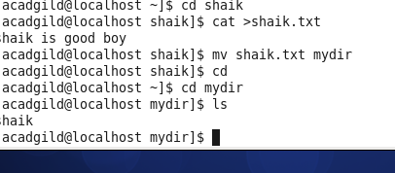

14.cp: The cp command is used to make copies of files and directories.

Example: cp file1.txt newdir

Copies the file1.txt in the working directory to the newdir subdirectory.

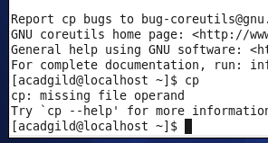

15.which: Locate the [executable file](https://www.computerhope.com/jargon/e/execfile.htm) associated with a given [command](https://www.computerhope.com/jargon/c/command.htm).

Example: which sh

Locates the pathname of the file which would be run if the [sh](https://www.computerhope.com/unix/ush.htm) command were executed:

